METHOD STATEMENT AND CHECKLIST

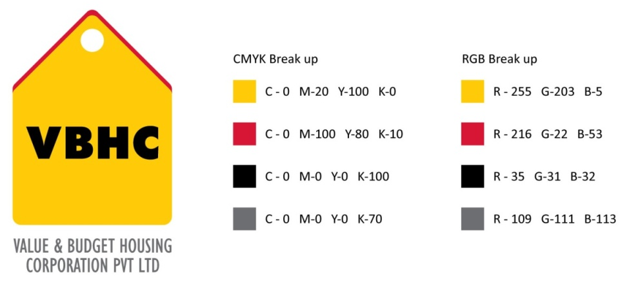
Document Control No : VBHC/QUA/P/02
Revision No : Rev 1.1
Date of Revision : 31st August 2023

 | Name/Designation | Signature | Date
Written By | Rakshith
Reviewed By | Shivaprasad

HISTORY OF REVISIONS

Revision No. | Revision Date | Chapter/clause no.  & text affected | Reason for Revision

TABLE OF CONTENTS
SL No. | CONTENTS | PAGE NO.
1. | Purpose | 1
2. | Process Trigger | 1
3. | Scope and Application | 1
4. | Process Owner  5. | 1
5. | Successor and Predecessor | 1
6. | Responsibilities & Authorities | 1
7. | Definitions and Abbreviations | 2
8. | Process Flow Chart | 2
9. | Process Description | 3
10. | Efficiency measures and effectiveness measures | 4
11. | Risk associated with the process | 4
12. | Formats for maintaining records | 4
13. | Records | 4
14 | Annexure I | 5

METHOD STATEMENT AND CHECK LIST

- PURPOSE
To develop Method Statements and Check Lists to demonstrate our understanding of the project requirements and the detailed methodology required to carry out project activities.

- PROCESS TRIGGER
None

- SCOPE AND APPLICATION
All construction activities at all VBHC sites

- PROCESS OWNER
Asst. Manager – Quality

- PREDECESSOR AND SUCCESSOR PROCESSES
Predecessor Process: None
Successor Process: Construction

- RESPONSIBILITY AND AUTHORITY

- DEFINITIONS & ABBREVIATIONS
- Writing method statements : Asst. Manager – Quality
- Approving method statements : COO

- PROCESS FLOW CHART
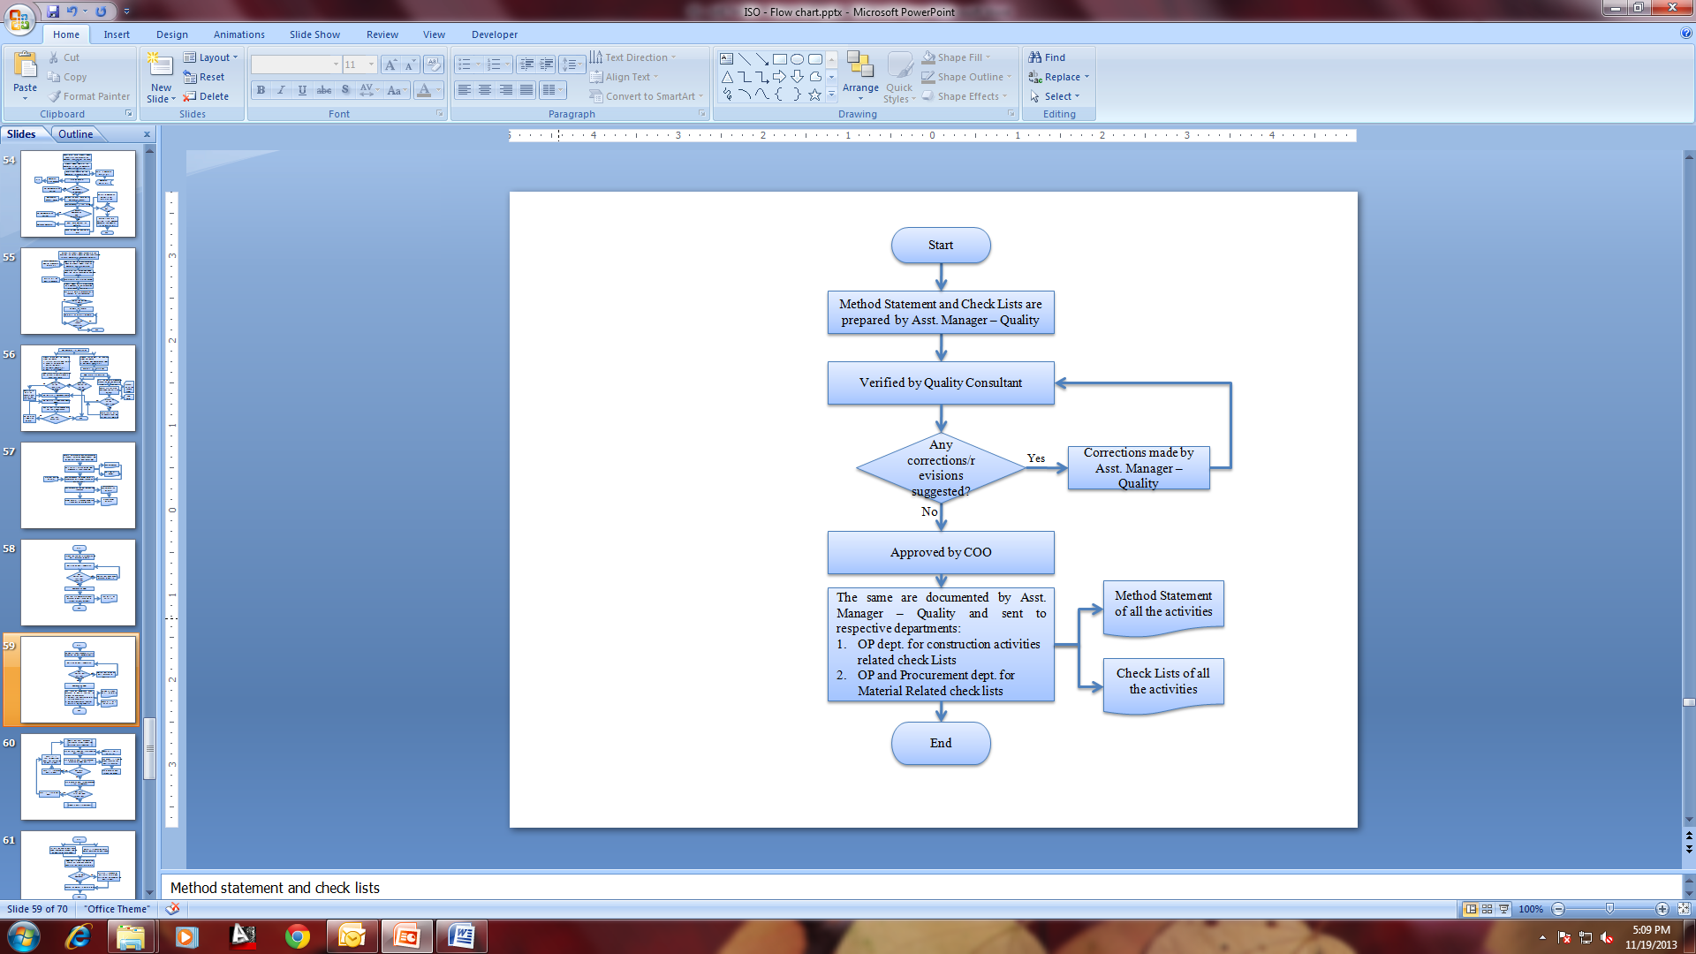

- PROCESS DESCRIPTION
  - A list of all works/activities required to be executed at VBHC projects is prepared. From this a list of method statements that need to be documented is drawn up.
  - Method Statement and its associated Check Lists are prepared by Asst. Manager – Quality.
  - The Method Statement should descried the following:
- The correct method of carrying out the activities for a specific job.
- Procedure to provide an induction document that worker must read and understand before starting a job.
- Guidelines to meet legal requirements, that is, hazard identification and control.
- Guideline to program the work, materials, time, staff, and to anticipate possible problems
- Parameters that define the quality of the output and items of inspection.
    - The Method Statement and Checklist are prepared at the beginning of the project and are expanded when new information becomes known throughout the project period.
  - Prepared Method Statement and Check Lists are sent for review to Quality Consultant and the recommendations are incorporated in the method statement.
  - The final method statement document is approved by COO
  - The Method Statements and Check Lists are documented by Asst. Manager – Quality and sent to OP dept. for construction activities related check Lists.
  - The method statements are periodically reviewed for their continued applicability.
    - In case repeated or frequent defects or non-conformities are reported related to any method statement, the same is reviewed with a view to identifying root cause attributable to the document and eliminating the same by suitable revisions

- EFFECIENCY MEASURES AND EFFECTIVENESS MEASURES
Efficiency Measures:
Effectiveness Measures: Quality of construction achieved based on the method statement
- RISK ASSOCIATED WITH THE PROCESS

- FORMATS FOR MAINTAINING RECORDS GENERATED IN THE PROCESS

- RECORDS
Method Statements of all the activities – Minimum Retention Period - Permanent
Check Lists of all the activities – Minimum Retention Period – Till Project Completion

ANNEXURE I
Name of Format | Code
Finishing Checklist - Floor Tile - Pre Check | VBHC/QUA/F/04
Finishing Checklist - Floor Tile - Post Check | VBHC/QUA/F/05
Finishing Checklist - Granite / Marble | VBHC/QUA/F/06
Finishing Checklist - Painting | VBHC/QUA/F/07
Finishing Checklist - Wall Tile | VBHC/QUA/F/08
Finishing Checklist - Waterproofing - Bath/Toilet | VBHC/QUA/F/09
Finishing Checklist - Waterproofing - Construction Joint | VBHC/QUA/F/10
Finishing Checklist - Waterproofing - OHT | VBHC/QUA/F/11
Finishing Checklist - Waterproofing - Terrace | VBHC/QUA/F/12
Finishing Checklist - Wood Works | VBHC/QUA/F/13
Finishing Checklist - Waterproof - Expansion joint | VBHC/QUA/F/14
Structure checklist - beams & slabs | VBHC/QUA/F/15
Structure checklist - Clearance from structural works | VBHC/QUA/F/16
Structure checklist - Column | VBHC/QUA/F/17
Structure checklist - Excavation | VBHC/QUA/F/18
Structure checklist - Footing | VBHC/QUA/F/19
Structure checklist - Formwork | VBHC/QUA/F/20
Structure checklist - PCC | VBHC/QUA/F/21
Structure checklist - Reinforcement | VBHC/QUA/F/22
Structure checklist - Soling | VBHC/QUA/F/23
Structure checklist - Wall | VBHC/QUA/F/24
Structure checklist – western form | VBHC/QUA/F/25
Plumbing - Pressure Test format | VBHC/QUA/F/26
Plumbing - CP Sanitary | VBHC/QUA/F/27
Plumbing - Handing Over | VBHC/QUA/F/28
Plumbing - CP & Sanitary work | VBHC/QUA/F/29
Electrical - Clearance | VBHC/QUA/F/30
Electrical - Kit Fixing - Internal | VBHC/QUA/F/31

